Question 1.

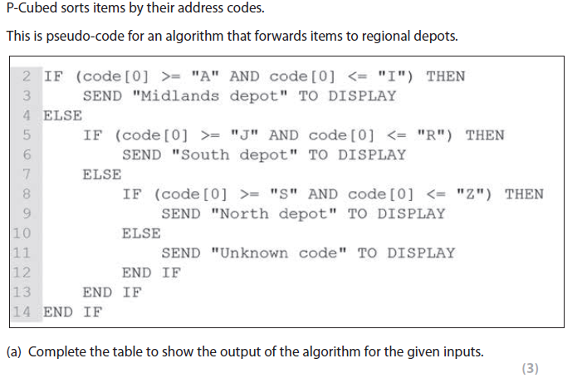

|  |  |
| --- | --- |
| Code | Output Displayed |
| QB7698RI | South depot |
| VA2288ZA | North Depot |
| 4W56AB92 | Unknown code |

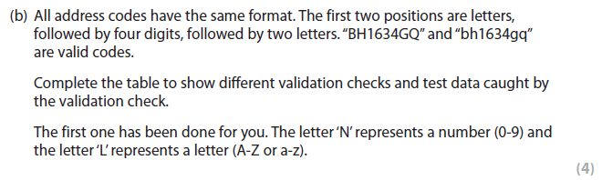

|  |  |
| --- | --- |
| **Validation Check** | **Test Data** |
| **Pattern Check (“LLNNNNLL”)** | **“4W56AB92”** |
| Length Check – 8 characters | “QW1453HG” – true “QW30294HG” – false |
|  |  |

**Question 2 (a)**

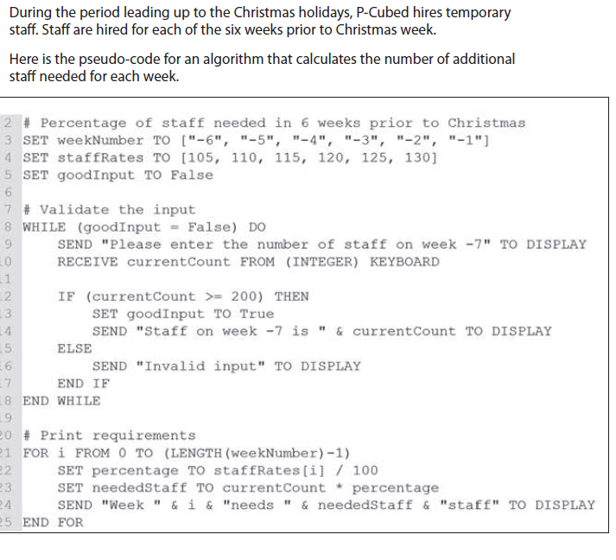

1. Complete the table to identify line number(s) that illustrate an example of different programming constructs. (4 marks)

|  |  |
| --- | --- |
| Programming Construct | Line Number(s) |
| A condition controlled loop | Line 8 |
| A comment | Line 2, 7, 20 |
| A selection construct | Line 12 |
| A subprogram call |  |

1. State the data type for variable ‘goodInput’ (1 marks)

Boolean

1. State the data type for variable ‘percentage’ (1 marks)

Float

(b) Complete the trace table to show execution of lines 21 to 25 of the pseudo-code for the fourth week before Christmas when the user enters the value 300. (6 marks)

|  |  |  |  |  |  |
| --- | --- | --- | --- | --- | --- |
| currentCount | i | LENGTH(weekNumber | percentage | staffRates[i] | neededStaff |
| 300 | 0 | 6 | 1.05 | 105 | 315 |
| 315 | 1 | 6 | 1.10 | 110 | 346.5 |
| **346.5** | **2** | **6** | **1.15** | **115** | **398.475** |
|  |  |  |  |  |  |
|  |  |  |  |  |  |

(c) State the largest number the user could enter on line 10 to cause the message ‘Invalid input’ to be displayed. ( 1 mark)

199